- Write a C program to simulate SJF scheduling algorithm non preemptive
#include<stdio.h>
int main()
{
int n,i,j,temp;
int at[10],bt[10],ct[10],tat[10],wt[10],p[10];
float avg_tat=0, avg_wt=0;
printf("Enter number of processes: ");
scanf("%d",&n);
for(i=0;i<n;i++)
{
p[i]=i+1;
printf("Arrival time of P%d:",i+1);
scanf("%d",&at[i]);
printf("Burst time of P%d:",i+1);
scanf("%d",&bt[i]);
}
for(i=0;i<n;i++)
{
for(j=i+1;j<n;j++)
{
if(bt[i] > bt[j])
{
temp=bt[i];
bt[i]=bt[j];
bt[j]=temp;
temp=at[i];
at[i]=at[j];
at[j]=temp;
temp=p[i];
p[i]=p[j];
p[j]=temp;
}
}
}
ct[0]=at[0]+bt[0];
for(i=1;i<n;i++)
ct[i]=ct[i-1]+bt[i];
for(i=0;i<n;i++)
{
tat[i]=ct[i]-at[i];
wt[i]=tat[i]-bt[i];
avg_tat += tat[i];
avg_wt += wt[i];
}
printf("\nP\tAT\tBT\tCT\tTAT\tWT\n");
for(i=0;i<n;i++)
printf("P%d\t%d\t%d\t%d\t%d\t%d\n",p[i],at[i],bt[i],ct[i],tat[i],wt[i]);
printf("\nAverage Turnaround Time = %.2f", avg_tat/n);
printf("\nAverage Waiting Time = %.2f", avg_wt/n);
return 0;
}

Output:
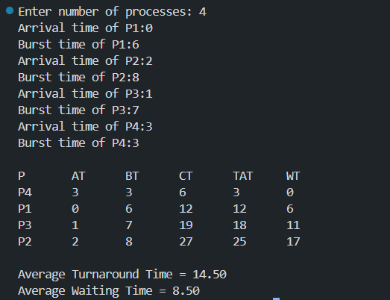

2. Write a C program to simulate SJF scheduling algorithm preemptive.
#include<stdio.h>
#include<limits.h>
int main()
{
int n,i,time=0,smallest;
int at[10],bt[10],rt[10],ct[10],tat[10],wt[10],start[10];
int completed=0;
float avg_wt=0,avg_tat=0,avg_rt=0;
printf("Enter number of processes: ");
scanf("%d",&n);
for(i=0;i<n;i++)
{
printf("Arrival time of P%d: ",i+1);
scanf("%d",&at[i]);
printf("Burst time of P%d: ",i+1);
scanf("%d",&bt[i]);
rt[i]=bt[i];
start[i]=-1;
}
while(completed!=n)
{
smallest=-1;
for(i=0;i<n;i++)
{
if(at[i]<=time && rt[i]>0)
{
if(smallest==-1 || rt[i]<rt[smallest])
smallest=i;
}
}
if(smallest==-1)
{
time++;
continue;
}
if(start[smallest]==-1)
start[smallest]=time;
rt[smallest]--;
time++;
if(rt[smallest]==0)
{
completed++;
ct[smallest]=time;
tat[smallest]=ct[smallest]-at[smallest];
wt[smallest]=tat[smallest]-bt[smallest];
avg_tat+=tat[smallest];
avg_wt+=wt[smallest];
avg_rt+=start[smallest]-at[smallest];
}
}
printf("\nP\tAT\tBT\tCT\tTAT\tWT\tRT\n");
for(i=0;i<n;i++)
printf("P%d\t%d\t%d\t%d\t%d\t%d\t%d\n",
i+1,at[i],bt[i],ct[i],tat[i],wt[i],start[i]-at[i]);
printf("\nAverage Turnaround Time = %.2f",avg_tat/n);
printf("\nAverage Waiting Time = %.2f",avg_wt/n);
//printf("\nAverage Response Time = %.2f",avg_rt/n);
return 0;
}
Output:
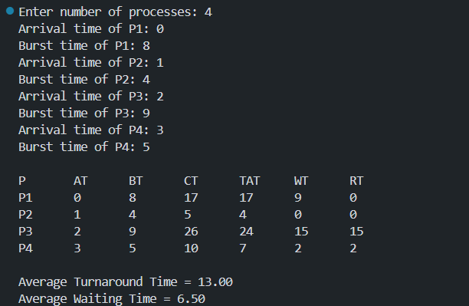

3. Write a C program to simulate priority scheduling algorithm non preemptive.
#include<stdio.h>
int main()
{
int n,i,j,temp;
int at[10],bt[10],pr[10],ct[10],tat[10],wt[10],p[10];
float avgwt=0,avgtat=0;
printf("Enter number of processes: ");
scanf("%d",&n);
for(i=0;i<n;i++)
{
p[i]=i+1;
printf("Arrival time of P%d: ",i+1);
scanf("%d",&at[i]);
printf("Burst time of P%d: ",i+1);
scanf("%d",&bt[i]);
printf("Priority of P%d: ",i+1);
scanf("%d",&pr[i]);
}
for(i=0;i<n;i++)
{
for(j=i+1;j<n;j++)
{
if(pr[i] > pr[j])
{
temp=pr[i];
pr[i]=pr[j];
pr[j]=temp;
temp=bt[i];
bt[i]=bt[j];
bt[j]=temp;
temp=at[i];
at[i]=at[j];
at[j]=temp;
temp=p[i];
p[i]=p[j];
p[j]=temp;
}
}
}
ct[0]=at[0]+bt[0];
for(i=1;i<n;i++)
ct[i]=ct[i-1]+bt[i];
for(i=0;i<n;i++)
{
tat[i]=ct[i]-at[i];
wt[i]=tat[i]-bt[i];
avgtat+=tat[i];
avgwt+=wt[i];
}
printf("\nP\tAT\tBT\tPR\tCT\tTAT\tWT\n");
for(i=0;i<n;i++)
printf("P%d\t%d\t%d\t%d\t%d\t%d\t%d\n",
p[i],at[i],bt[i],pr[i],ct[i],tat[i],wt[i]);
printf("\nAverage Turnaround Time = %.2f",avgtat/n);
printf("\nAverage Waiting Time = %.2f",avgwt/n);
return 0;
}
Output:
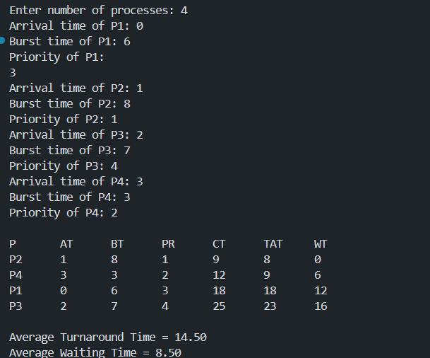

4. Write a C program to simulate priority scheduling algorithm preemptive.
#include<stdio.h>
int main()
{
int n,i,time=0,completed=0,highest;
int at[10],bt[10],pr[10],rt[10];
int ct[10],tat[10],wt[10],start[10];
float avgwt=0,avgtat=0,avgrt=0;
printf("Enter number of processes: ");
scanf("%d",&n);
for(i=0;i<n;i++)
{
printf("Arrival time of P%d: ",i+1);
scanf("%d",&at[i]);
printf("Burst time of P%d: ",i+1);
scanf("%d",&bt[i]);
printf("Priority of P%d: ",i+1);
scanf("%d",&pr[i]);
rt[i]=bt[i];
start[i]=-1;
}
while(completed!=n)
{
highest=-1;
for(i=0;i<n;i++)
{
if(at[i]<=time && rt[i]>0)
{
if(highest==-1 || pr[i] < pr[highest])
highest=i;
}
}
if(highest==-1)
{
time++;
continue;
}
if(start[highest]==-1)
start[highest]=time;
rt[highest]--;
time++;
if(rt[highest]==0)
{
completed++;
ct[highest]=time;
tat[highest]=ct[highest]-at[highest];
wt[highest]=tat[highest]-bt[highest];
avgtat+=tat[highest];
avgwt+=wt[highest];
avgrt+=start[highest]-at[highest];
}
}
printf("\nP\tAT\tBT\tPR\tCT\tTAT\tWT\tRT\n");
for(i=0;i<n;i++)
printf("P%d\t%d\t%d\t%d\t%d\t%d\t%d\t%d\n",
i+1,at[i],bt[i],pr[i],ct[i],tat[i],wt[i],start[i]-at[i]);
printf("\nAverage Turnaround Time = %.2f",avgtat/n);
printf("\nAverage Waiting Time = %.2f",avgwt/n);
//printf("\nAverage Response Time = %.2f",avgrt/n);
return 0;
}
Output:
